----------Adviser Tab----------

Figure 1. Adviser Login Page

* The Adviser is required to input a Faculty Number as well as their Password to be able to logged into the system.
* Adviser Accounts will be created by the OJT Coordinator.

Figure 2. Adviser Class List

* This is a full view of all created classes by the OJT Adviser where students were enrolled and monitored.
* Log out Button – To end session.
* Create Class Button – To create a class for the students.
* Visit Class – Direct the Adviser to his/her class.
* [Sidebar] Adviser Work – To edit student profile Information.

Figure 3. Create Class

* This allows the OJT advisers to create a class and fill out the information of the class which he/she will handle.
* Create Button – Will create class after filling out required information needed in creating a class.
* Cancel Button – to go back to Adviser Class List.

Figure 4. Adviser Work

* Will show announcements and submission bin created by the OJT Coordinator for his/her Adviser.
* Submit Button – to submit required documents need by the OJT Coordinator.

Figure 5. Adviser Dashboard

* Will display all numerical summary of contents which can be clicked and view a specific content.
* Notification Bell – to notify all created posts and comments by his/her students.
* Classwork Buttons
  + Students Button – to view all Students enrolled in the class.
  + Graded Task Button – to view all your Graded Task.
  + Ungraded Task Button – to view all your Ungraded Task.
* On the Job Training Process Buttons
  + In Process Button – to view all students still in process of their requirements.
  + On going Button – to view all students who’s On Going with their OJT.
  + Graphical user interface

    Description automatically generated with medium confidenceCompleted Button – to view all students already Completed with their required hours.

Figure 6: Classwork

* This is where the OJT Adviser can create assignments to give to his/her students as well as grade and accepts documents submitted by the students.
* Export to CSV Button – Will export all created assignments with information of who submitted their assignments and together with their grades (if it is graded).
* Deleted Button – to view all deleted assignments.
* Create Assignment Button – to create an assignment for the students.

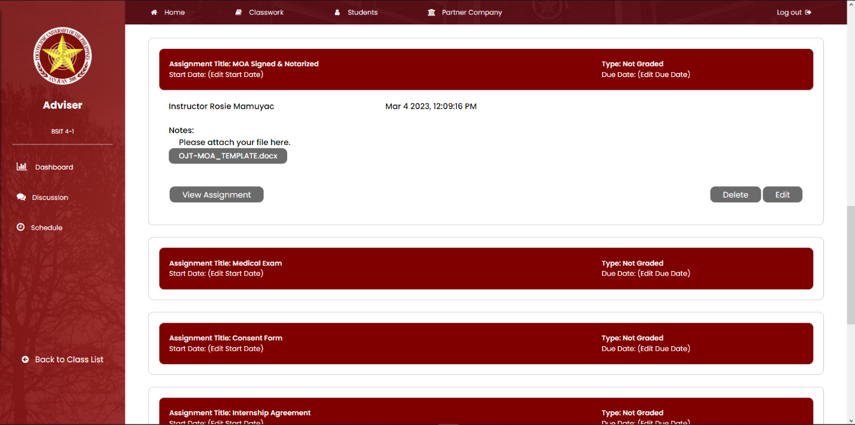

Figure 7. View Assignment

* View Assignment Button – to view all assignments submitted by the students.
* Deleted Button – to delete created assignment.
* Edit Button – to edit the information in the created assignment.

Figure 8: View all Assignment

* Edit Grades Button – to edit all selected assignments.
* View Assignment Button – to view the submitted assignment of the student

Figure 9: Students

* This is where the OJT Adviser can View, Edit and Delete students information such as their email addresses. Contact numbers, and their company.
* Enroll Student Button – to Upload a CSV file to upload students to be enrolled in the class.
* Trash Button – to view deleted student information and possible to retrieve the information.
* Edit Students Information Button – to edit multiple student information.
* Action Buttons
  + View Button – to view all student information.
  + Edit Button – to edit individual student information.
  + Delete Button – to delete a student information.

Figure 10: Partner Company List

* This is where the OJT Coordinator can view all Partnered Companies as well as print company information.
* Print List Button – to print all partner company list.
* Inactive Company Button – to view all Inactive companies.
* Advance Filter Button – to display specific company using a filter.
* Action Button
  + View Button – to view full information of the company.

Figure 11: Discussion

* This is where the Adviser can Post any announcements and documents to share with his/her class.
* Rules and Reminder Button – to remind the user about what to consider when posting an announcement in the discussion.
* Choose file button - to let the user upload a file when posting.
* Post Button – to be able to post a announcement or document.
* Edit Button – for the Adviser to edit his/her own post.
* Delete Button – for the Adviser to delete his/her post as well as the students post.
* View Comment – for the Adviser to be able to comment on his/her post as well as other post.
  + Post Button (View Comment) – to be able to post comments.

Figure 12: Schedule

* This is where the OJT Adviser can set a scheduled meeting to monitor as well as mentor students in handling issues at the workplace.
* History Button – to view all completed scheduled meeting dates.
* Create Schedule Button – to create a schedule for mentoring/ monitoring.
* Action Button
  + Edit Button – to be able to edit scheduled information.
  + Delete Button – to be able to delete scheduled information.

Figure 13: Mentoring Schedule

* Submit Button – to create a scheduled mentoring once all required information is filled.
* Close Button - to cancel creating a scheduled meeting.